Name : M Sanjay Krishna Course : Cloud computing
Reg no : 192525421 Code : CSA1513

1.CLOUD-BASED FLIGHT RESERVATION SYSTEM
AIM
To design and develop a simple Cloud-Based Flight Reservation System using HTML, CSS, and JavaScript to demonstrate the basic concept of Software as a Service (SaaS).
PROCEDURE
1. Create an HTML file named flight.html.
2. Design the Flight Reservation System using HTML.
3. Apply CSS to create a user-friendly interface.
4. Provide options for One Way and Round Trip.
5. Provide Domestic and International flight options.
6. Enter From, To, Departure Date, and Return Date.
7. Select the number of Travelers, Class, and Fare Type.
8. Use JavaScript to validate the entered details.
9. Click Search Flights to display the reservation details.
10. Deploy the application on a cloud platform to demonstrate SaaS.
PSEUDOCODE
START
Display Flight Reservation Form
Select One Way or Round Trip
Select Domestic or International
Enter From, To and Departure Date
Enter Return Date if Round Trip
Select Travelers, Class and Fare Type
Click Search Flights
IF From = To
Display "Invalid Destination"
ELSE
Display Flight Details
END IF
STOP
OUTPUT
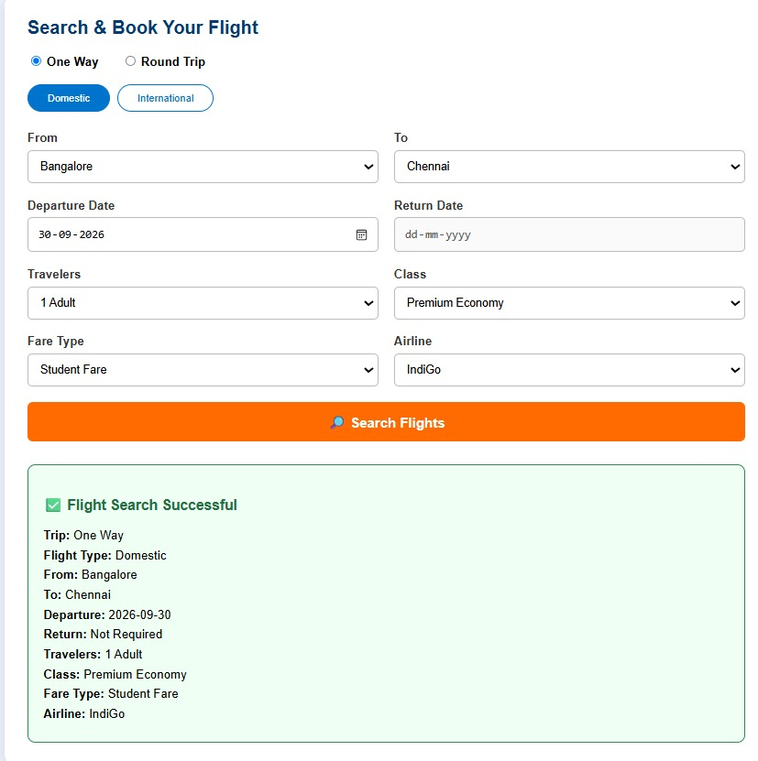
RESULT
Thus, a simple Flight Reservation System was successfully created using HTML with the required reservation fields.

2 – Property Buying & Rental System
Aim
To create a simple Property Buying and Rental System for Chennai using HTML, CSS, and JavaScript with options for Buy, Rent, Commercial property, Rental Agreement, Area, Place, Price Range, Property Value, and BHK.
Procedure
- Create an HTML file.
- Design the Property Buying and Rental System using HTML.
- Add CSS to improve the appearance of the application.
- Add options for Buy, Rent, and Commercial properties.
- Add fields for Rental Agreement, Area, Place, Price Range, Property Value, and BHK.
- Add a Search Property button.
- Use JavaScript to get the entered property details.
- Validate the Area and Property Value fields.
- Display the property details after clicking the Search Property button.
- Save the file as property.html.
- Open the file in a web browser and test the application.
Pseudocode:
START
Display Property Buying and Rental System
Select Property Type
Select Rental Agreement
Enter Area
Select Place
Select Price Range
Enter Property Value
Select BHK
Click Search Property
IF Area or Property Value is empty
Display "Please enter Area and Property Value"
ELSE
Display all property details
Display "Property details submitted successfully"
END IF
STOP
Output
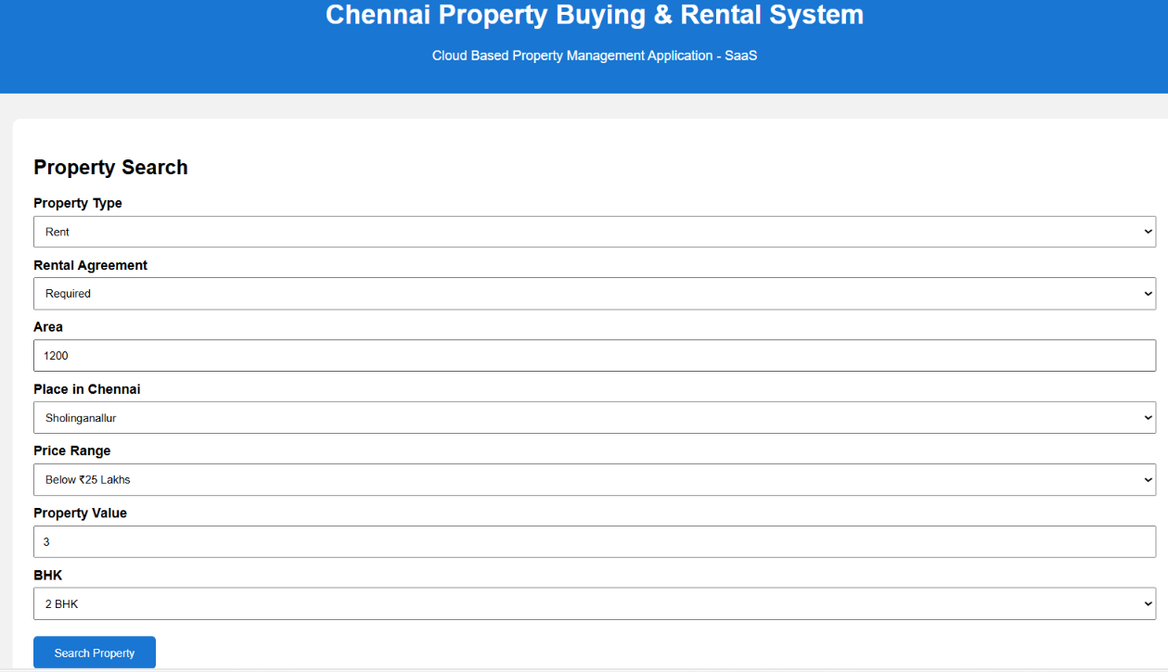
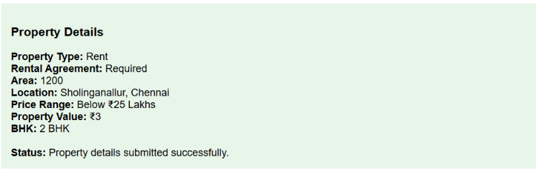
Result:
Thus, the Chennai Property Buying and Rental System was successfully created using HTML, CSS, and JavaScript with the required property search and rental details.
3 – Car Booking Reservation System
Aim
To create a simple Car Booking Reservation System using HTML, CSS, and JavaScript with options for From, To, Rental, Out Station, Package Type, and Hours/Days.
Procedure
- Create an HTML file.
- Design the Car Booking Reservation System using HTML.
- Apply CSS to style the application.
- Add From and To fields.
- Add Rental and Out Station options.
- Add Package Type.
- Add Hours/Days field.
- Add the Search Cabs button.
- Use JavaScript to validate the entered details.
- Display the cab booking details.
- Save the file as carbooking.html.
- Open the file in a web browser and test the application.
Pseudocode
START
Display Car Booking Reservation System
Enter From
Enter To
Select Booking Type
Select Package Type
Enter Hours/Days
Click Search Cabs
IF From or To or Hours/Days is empty
Display error message
ELSE
Display cab booking details
Display successful submission
END IF
STOP
Output:
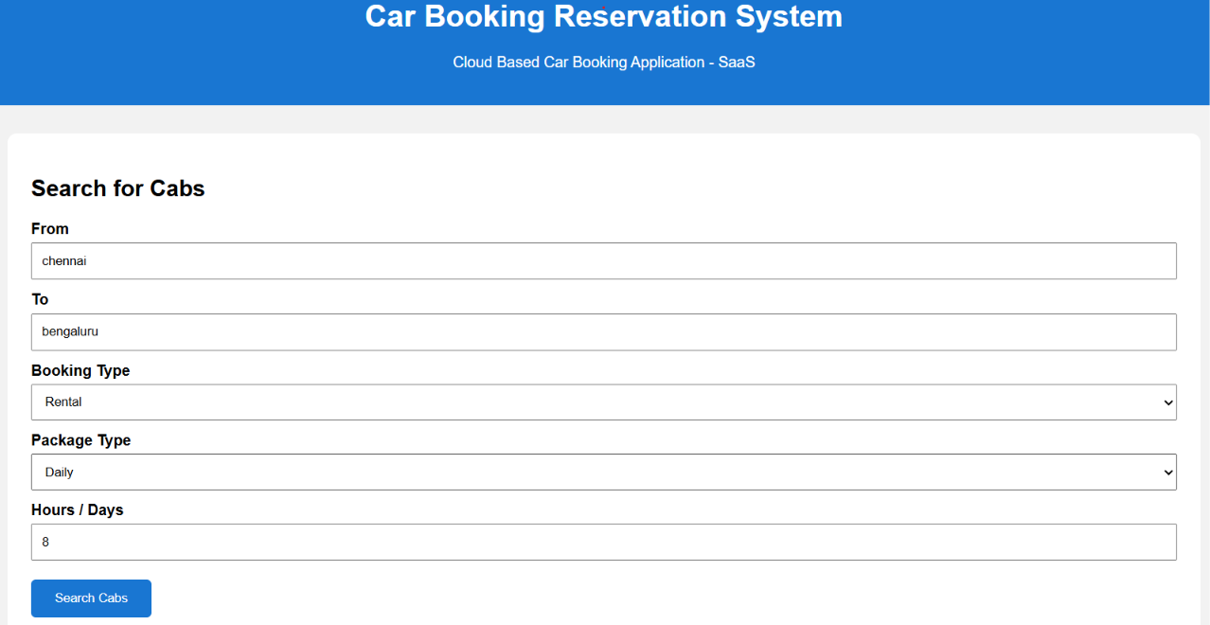
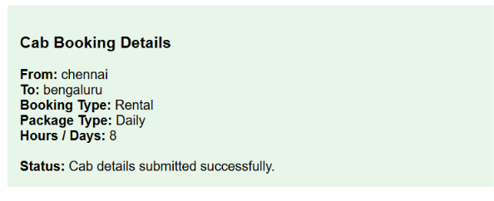
Result:
Thus, the Car Booking Reservation System was successfully created using HTML, CSS, and JavaScript with the required cab booking fields.

4 – Library Book Reservation System
Aim
To create a simple SIMATS Library Book Reservation System using HTML, CSS, and JavaScript with details such as book title, author, publication, year, edition, number of copies, rack number, and book status.
Procedure
- Create an HTML file.
- Design the SIMATS Library Book Reservation System.
- Add fields for Title, Author, Publication, Year and Edition.
- Add No. of Copies and Rack No. fields.
- Add Taken/Returned status.
- Add the Reserve Book button.
- Use JavaScript to validate the entered details.
- Check the book availability based on copies and status.
- Display the book reservation details.
- Save the file as library.html.
- Open the file in a web browser and test it.
Pseudocode
START
Display Library Book Reservation System
Enter Title
Enter Author
Enter Publication
Enter Year
Enter Edition
Enter Number of Copies
Enter Rack Number
Select Status
Click Reserve Book
IF Title or Author or Copies is empty
Display error message
ELSE IF Status is Returned AND Copies > 0
Display "Book Available for Reservation"
ELSE
Display "Book Taken"
END IF
STOP
Output:
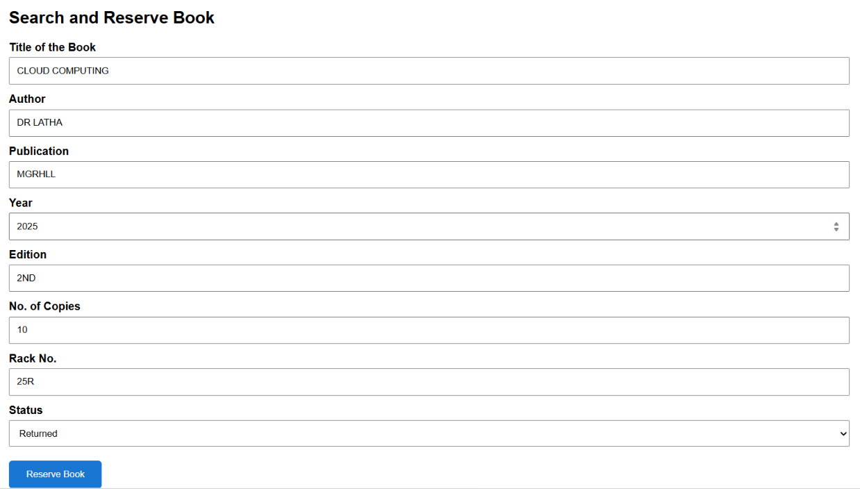
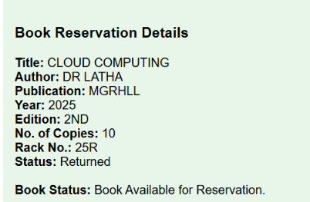
Result
Thus, the SIMATS Library Book Reservation System was successfully created with the required book details and availability status.

5 – Mark Sheet Processing System
Aim
To create a simple Mark Sheet Processing System using HTML, CSS, and JavaScript to calculate total marks, average, percentage, rank, and overall performance.
Procedure
- Create an HTML file.
- Design the Mark Sheet Processing System.
- Add Student Name and Register Number fields.
- Add marks fields for different subjects.
- Add the Process Mark Sheet button.
- Use JavaScript to calculate total and average marks.
- Calculate the percentage.
- Display the overall performance based on the percentage.
- Display the mark sheet details.
- Save the file as marksheet.html.
- Open the file in a web browser and test the application.
Pseudocode
START
Enter Student Name
Enter Register Number
Enter marks of 5 subjects
Calculate Total Marks
Calculate Average
Calculate Percentage
IF Percentage >= 90
Performance = Excellent
ELSE IF Percentage >= 75
Performance = Very Good
ELSE IF Percentage >= 50
Performance = Good
ELSE
Performance = Needs Improvement
Display Total
Display Average
Display Percentage
Display Rank
Display Overall Performance
STOP
Output:
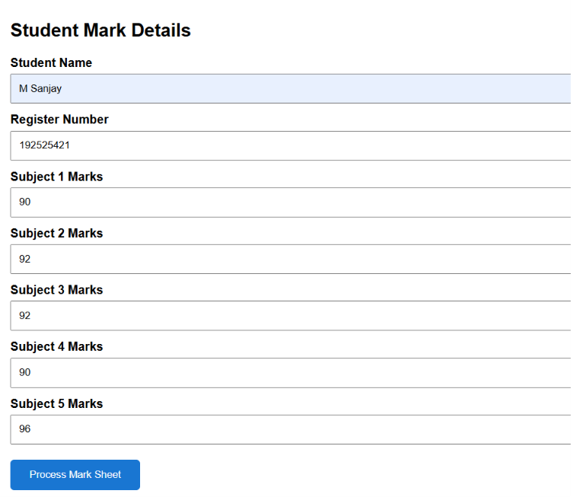
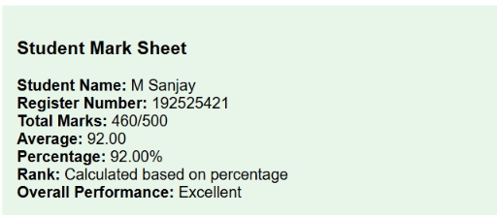

Result:
Thus, the Mark Sheet Processing System was successfully created to process student marks and display average, percentage, rank, and overall performance.

6 – Payroll Processing System
Aim
To design and develop a Payroll Processing System using HTML, CSS and JavaScript to calculate gross pay and net pay.
Procedure
- Create an HTML file.
- Design the payroll form using HTML and CSS.
- Enter employee name and experience details.
- Enter Basic Pay, HRA, DA and TA.
- Use JavaScript to calculate Gross Pay.
- Calculate Net Pay.
- Display all payroll details.
- Run the HTML file in a browser.
Pseudocode
START

Read employee name
Read present organization experience
Read overall experience
Read basic pay
Read HRA
Read DA
Read TA
Gross Pay = Basic Pay + HRA + DA + TA
Net Pay = Gross Pay
Display employee details
Display Gross Pay
Display Net Pay
STOP
Output:

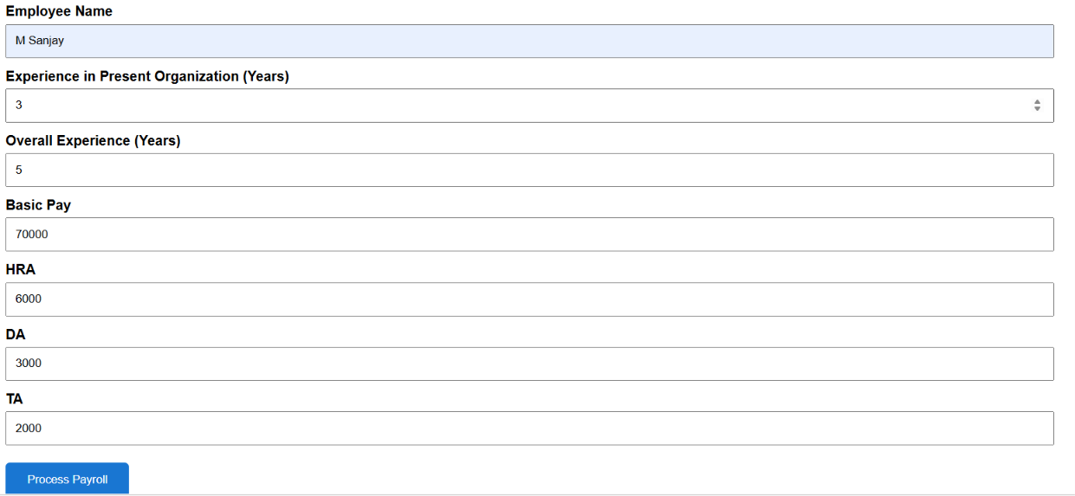

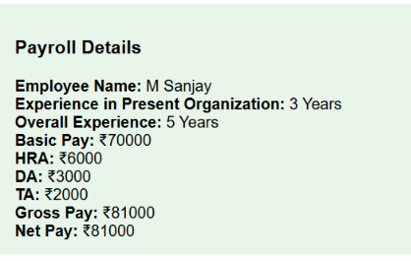
Result:
Thus, the Payroll Processing System was successfully designed and developed using HTML, CSS and JavaScript. The system accepts employee details, Basic Pay, HRA, DA and TA, and successfully calculates and displays the Gross Pay and Net Pay.

7 – Students Attendance System
Aim
To design and develop a Students Attendance System using HTML, CSS and JavaScript to calculate attendance percentage and grade.
Procedure
- Create an HTML file.
- Design the attendance form.
- Enter student name and course.
- Enter total, present and absent classes.
- Select the OD request.
- Calculate attendance percentage using JavaScript.
- Assign a grade based on attendance.
- Display the attendance details.
Pseudocode
START
Read student name
Read course
Read total classes
Read present classes
Read absent classes
Read OD request
Attendance Percentage =
(Present / Total) × 100
If percentage >= 90
Grade = A
Else if percentage >= 75
Grade = B
Else if percentage >= 60
Grade = C
Else
Grade = D
Display attendance details
Display grade
STOP

Output:

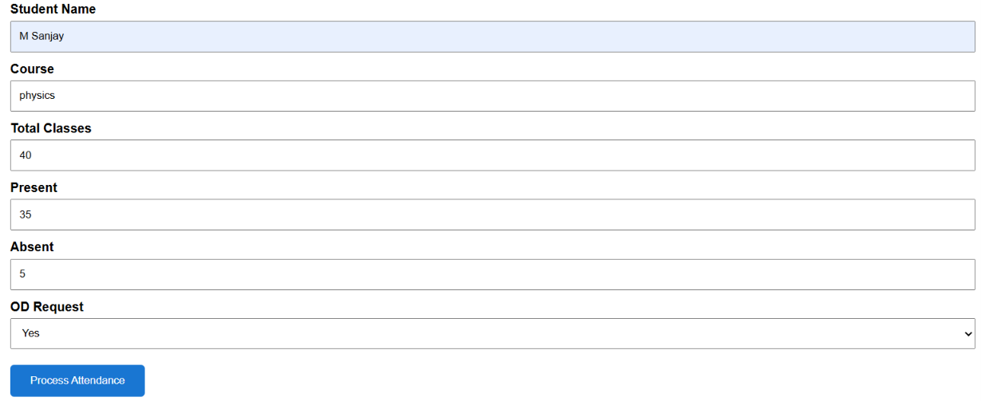
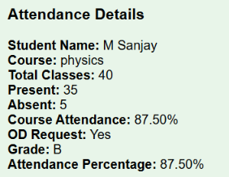
Result:
Thus, the Students Attendance System was successfully designed and developed using HTML, CSS and JavaScript. The system accepts student and attendance details and calculates and displays the attendance percentage and grade.
8 – Student Counselling System
Aim
To design and develop a Student Counselling System using HTML, CSS and JavaScript to collect and display student counselling details.
Procedure
- Create an HTML file.
- Design the counselling form using HTML and CSS.
- Enter student personal details.
- Enter subjects studied and academic details.
- Select the student's domain interest.
- Use JavaScript to process the entered information.
- Display the counselling details.
Pseudocode
START

Read name
Read age
Read address
Read phone
Read subjects studied
Read year of passing
Read percentage
Read domain interest
If required details are empty
Display error message
Else
Display all counselling details
Display submission status
STOP
Output:

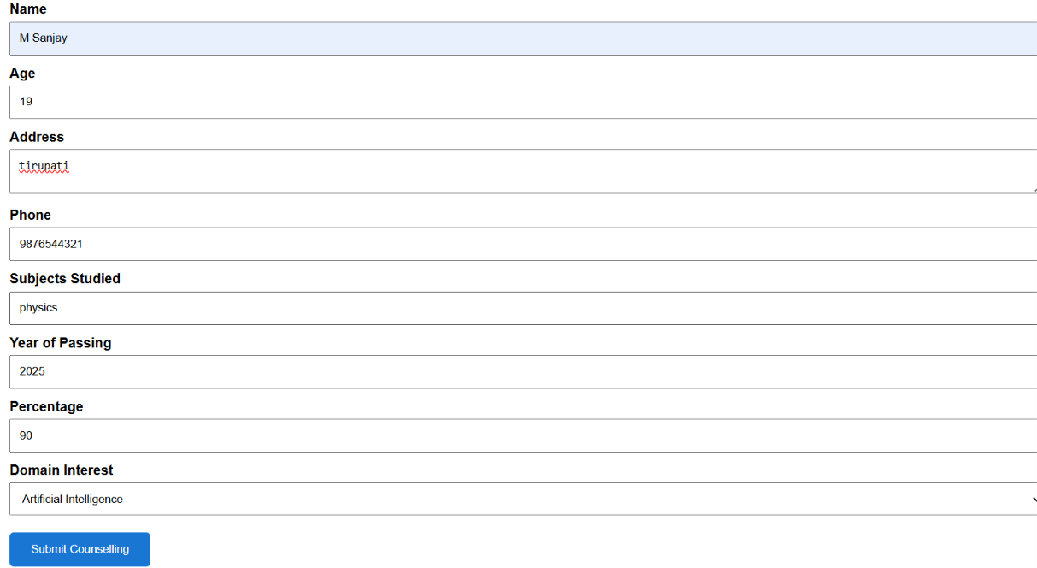
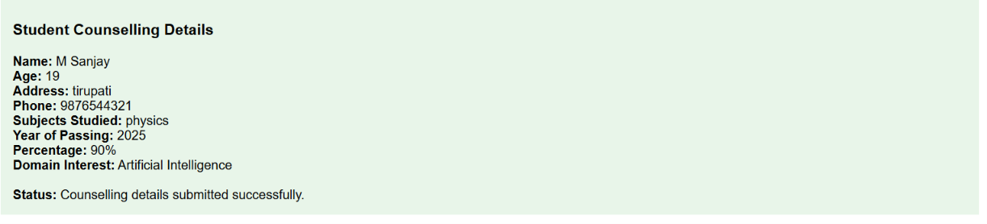
Result:
Thus, the Student Counselling System was successfully designed and developed using HTML, CSS and JavaScript. The system collects and displays the student's personal, academic and domain interest details.

9 – Hospital Information System
Aim
To design and develop a Hospital Information System using HTML, CSS and JavaScript to collect and display patient information.
Procedure
- Create an HTML file.
- Design the hospital information form.
- Enter patient details.
- Enter attender details.
- Enter doctor name and disease.
- Use JavaScript to process the details.
- Display the patient information.
Pseudocode
START
Read patient name
Read age
Read address
Read phone
Read email
Read attender name
Read attender phone
Read doctor name
Read diseases
If required details are empty
Display error message
Else
Display patient information
Display submission status
STOP
Output:

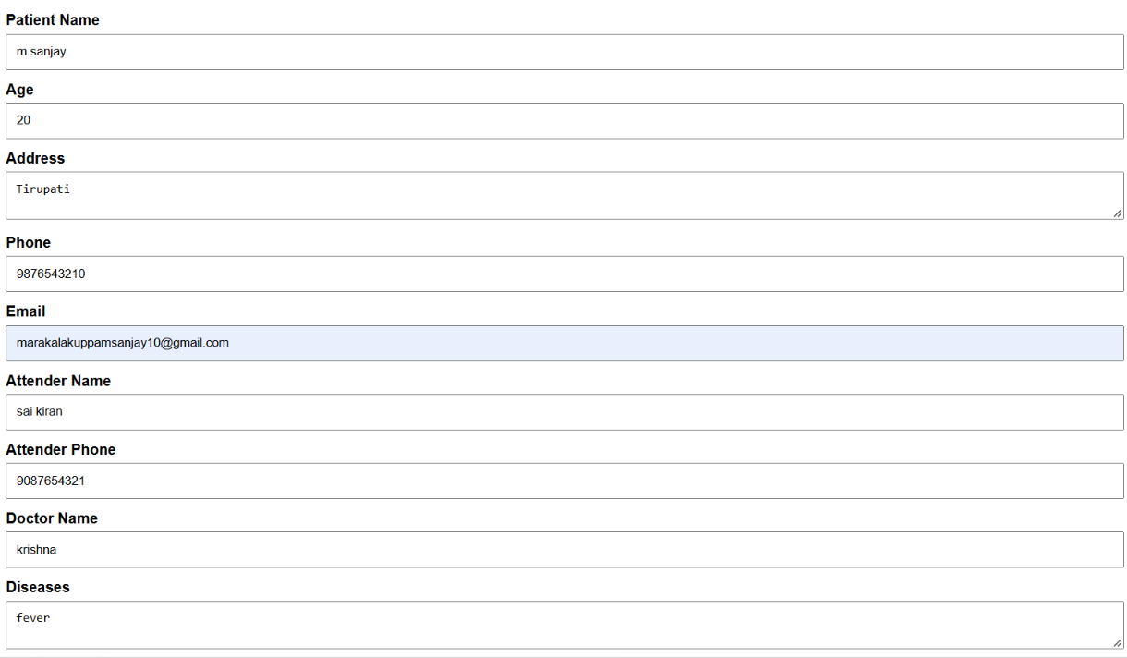
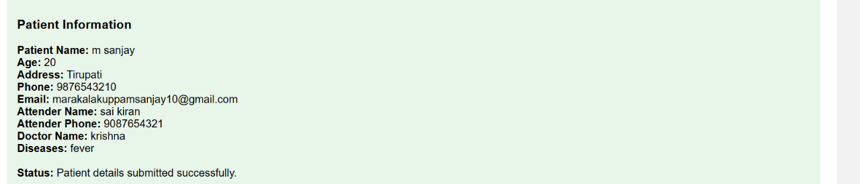
Result:
Thus, the Hospital Information System was successfully designed and developed using HTML, CSS and JavaScript. The system collects and displays patient, attender, doctor and disease details.
10 – C Program Student Information System
Aim
To design and develop a Student Information System to store and display student personal, academic, attendance and progress details.
Procedure
- Create an HTML file.
- Design the student information form.
- Enter student personal details.
- Enter course and grade details.
- Enter attendance and progress report.
- Enter semester marksheet details.
- Use JavaScript to process the information.
- Display all student details.
Pseudocode
START
Read student name
Read register number
Read address
Read phone
Read age
Read courses
Read grades
Read attendance
Read progress report
Read semester marksheet
If required details are empty
Display error message
Else
Display all student details
Display submission status
STOP
Output:
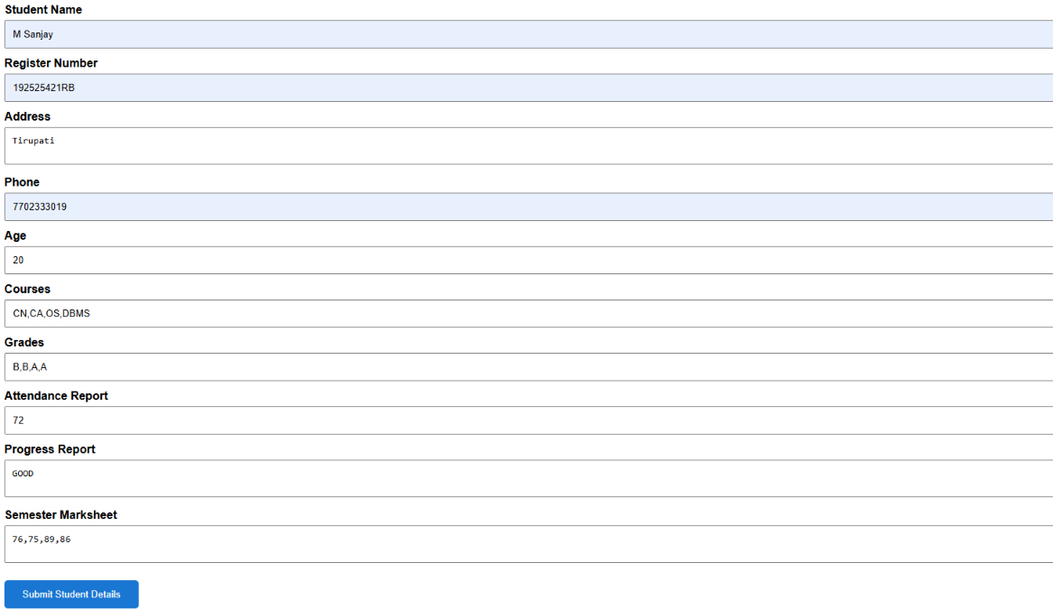
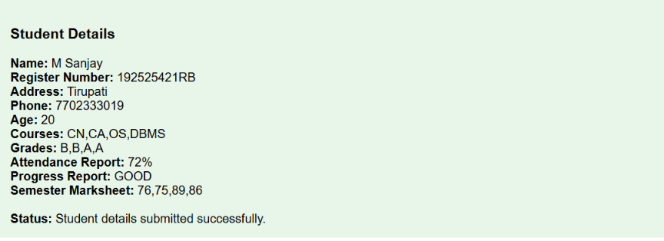
Result:
Thus, the Student Information System was successfully designed and developed using HTML, CSS and JavaScript. The system collects and displays student personal, course, grade, attendance, progress and semester marksheet details.
11 – Online Supermarket
Aim
To design and develop an Online Supermarket System using HTML, CSS and JavaScript to collect customer and item details.
Procedure
- Create an HTML file.
- Design the supermarket form.
- Enter customer details.
- Enter item and quantity.
- Select the item classification.
- Use JavaScript to process the order.
- Display the order details and status.
Pseudocode
START

Read customer name
Read address
Read phone
Read email
Read item
Read quantity
Read item classification

If required details are empty
Display error message
Else
Display order details
Display order status

STOP

Output:
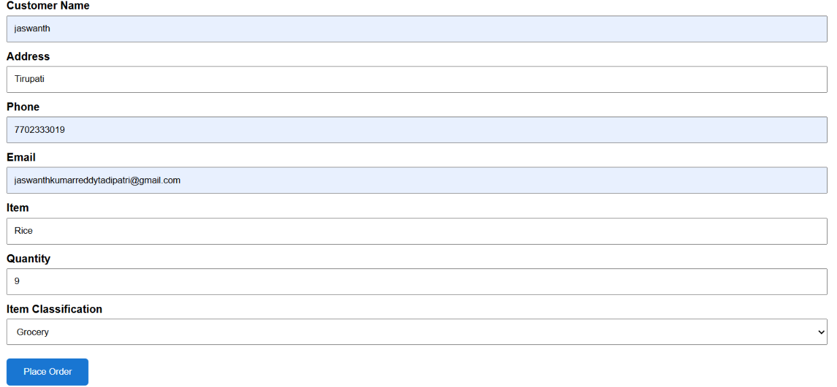
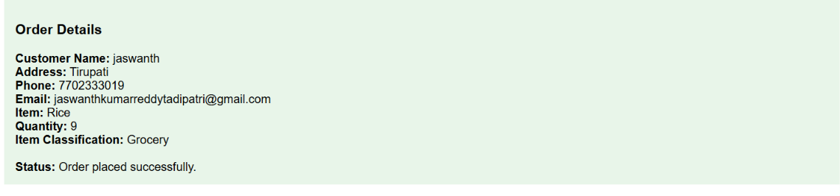
Result:
Thus, the Online Supermarket System was successfully designed and developed using HTML, CSS and JavaScript. The system accepts customer, item, quantity and item classification details and displays the order information successfully.

